**Change Tuples values, add or remove item**

Tuples are immutable, so values can’t be changed

But

1) Convert tuples to list

2) Add or remove item

3) Change list back to tuple

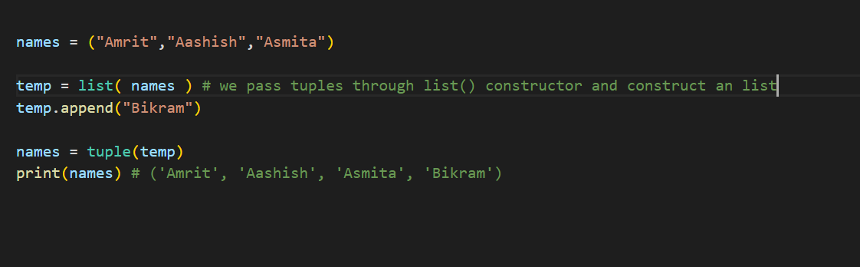

**del** keyword to completely permanently delete the tuple

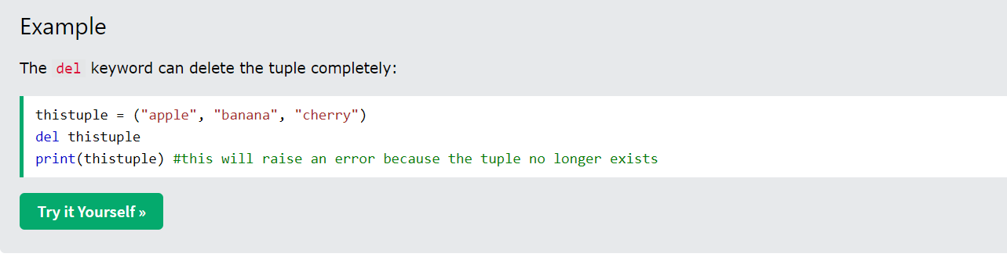

**Unpacking of tuples**

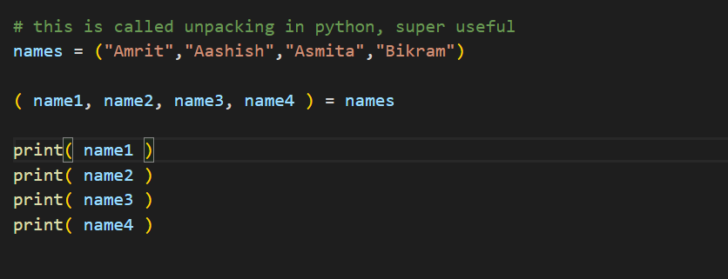

Super useful

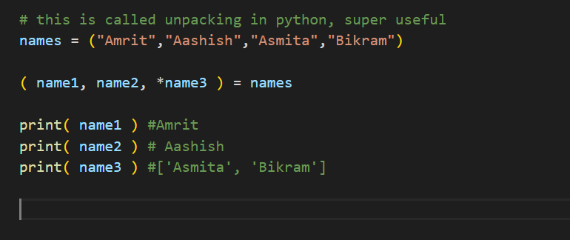

**len ( ) method to find the length of tuples**

while loop

